1. **Simulating skill of chlorophyll-a compared with remote sensing data:**

Remote sensing result of chlorophyll -a (Chl-a) produced by NEODC (http://data.ceda.ac.uk/neodc/esacci/ocean_colour/data/v2release/geographic/netcdf/chlor_a/monthly/v2.0/2006/) in July and August 2006 to verify the simulated Chl-a at sea surface as shown in the Supporting Information Figure 1 (c) and (d).

The trend and magnitude of Chl-a reflected by the satellite remote sensing in July and August are very similar to the monthly average results of the simulation. In the wet season of July and August, a large amount of terrestrial nutrients are imported into the estuary water, and the Chl-a showed a decreasing trend from outlets to open sea. The high-value areas of Chl-a appeared in the west of Lingdingyang for both of the remote sensing and simulating result. Generally speaking, the Chl-a of the open sea simulated by the model is slightly higher than that of the remote sensing data. However, the distribution pattern and concentration are within a reasonable range.

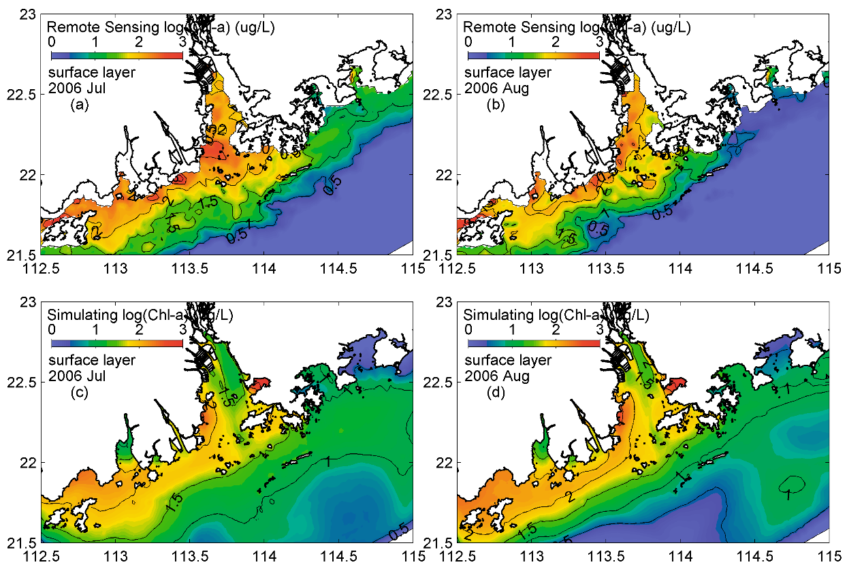

**Supporting Information Figure 1.** Horizontal distribution of remote sensing (upper panels) and simulated (down panels) Chl-a in July and August of 2006.

1. **Simulating skill of POC compared with remote sensing data:**

In the Supporting Information Figure 2, the remote sensing result of seasonal distribution of POC presented by Liu et al. (2015) and the simulating results of seasonal distribution of POC are shown. The results of remote sensing and model simulation show a highly similar distribution pattern of surface POC, that is, the rapid concentration attenuation from the outlets to the open sea. At the same time, under the effect of Coriolis force, the POC concentration in the west of Lingdingyang Bay is significantly higher than that in the East. It should be noted that the POC high-value area on the west side of Lingdingyang bay always exists during the whole year in the remote sensing result. While the remote sensing result is hard to reflect the seasonal POC variation affected by Chl-a and river plume; at the same time, in the east side of Lingdingyang bay, POC remote sensing results reflect the significant POC supplement process caused by phytoplankton explosion in summer and autumn. Compared with the remote sensing results, the model simulated the same distribution pattern with the remote sensing, and the POC concentration in the surface layer is higher in summer and lower in winter. Moreover, due to the growth of phytoplankton in summer, the POC in the eastern Lingdingyang bay is compensated by marine POC and results in a higher POC concentration in the open sea than that in winter.

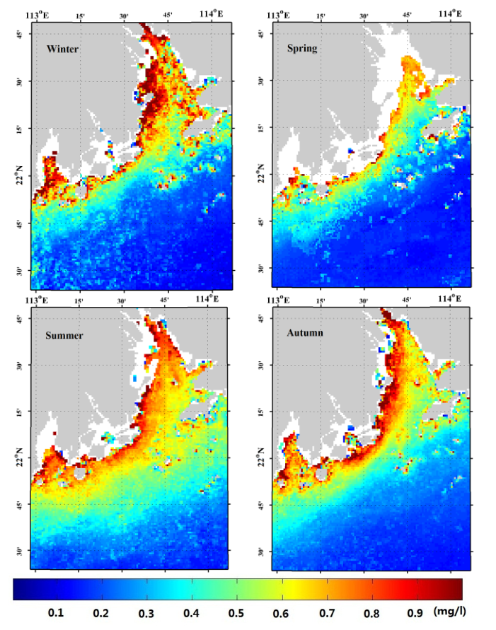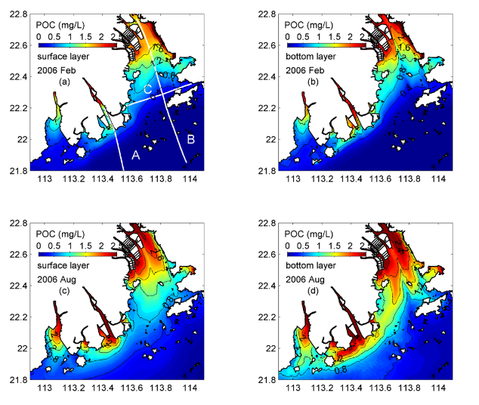

**Supporting Information Figure 2.** Horizontal distribution of four season remote sensing (1st and 2nd panels) and simulated (3rd and 4th panels) POC. Remote sensing data is supplied by Liu et al. (2015): Seasonal POC concentrations (mg/L) derived from the MODIS/AQUA data from 2002 to 2014 using the proposed algorithm. Each season is represented by a specific month: January for winter, April for spring, July for summer, and November for autumn (Liu et al., 2015).

1. **Simulating POC peak at middle layer:**

The POC-S relationship and Phytoplankton -S relationship of different water depth in August 2006 are shown in Supporting Information Figure 3. It can be seen that near the sea surface (water depth < 1.5 m), POC-S relationship match well with the curve (black line) presented by Guo et al. (2015), the POC intensively decreased while salinity increasing. However at the middle layer (water depth = 5.5 m), POC decreased while salinity increased from 0 to 3 psu, and then POC slightly increased while salinity increased from 3 to 28 psu, and POC intensively decreased while salinity increased from 28 to 30 psu, as shown in Supporting Information Figure 3 (a). The POC-S relationship at middle layer is obviously dominated by Chl-a as shown in Supporting Information Figure 3 (b). Therefore, there exist the POC peak due to phytoplankton bloom in the simulation result. However, the POC peak in simulating result occurs at middle layer instead of the surface layer at 0.5 m (Guo et al., 2015) or 1 m (He et al., 2010) presented by previous studies. This phenomenon may cause by complicated biogeochemical processes and contains local features.

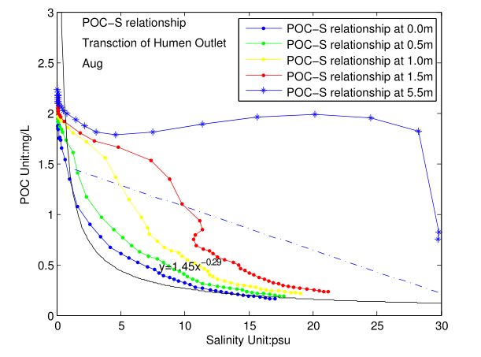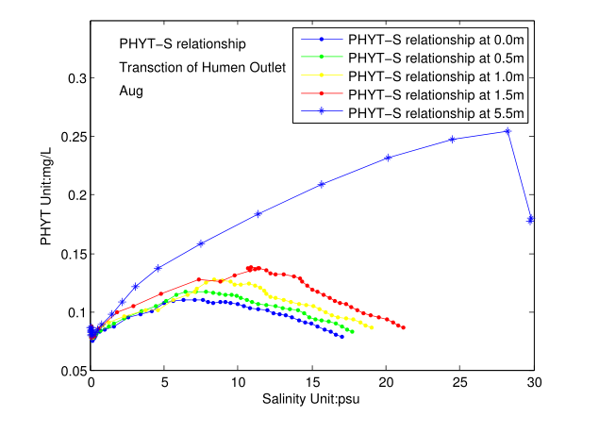

**Supporting Information Figure 3.** August POC-Salinity (a) and Phytoplankton-Salinity (b) relationship at different water depth simulated by carbon cycle model at Transection B as shown in the manuscript Figure 1.

1. Simulating nitrification rate compared with previous estimating

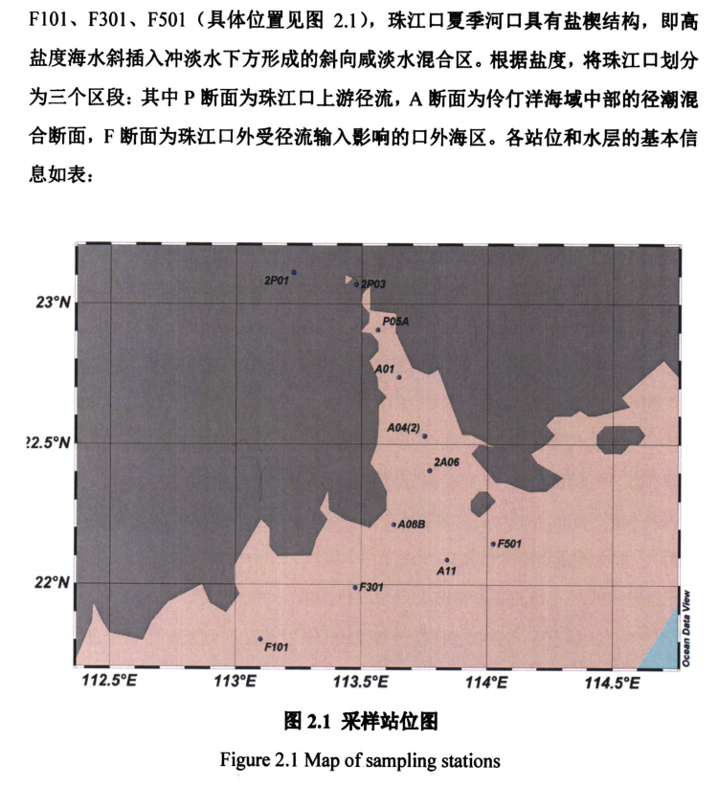

**Supporting Information** Figure 4: Map of sampling station in Zhang et al. (2016) for nitrification rate in PRE.

Zhang (2016) observed the nitrification rate of PRE during 6th July 2015 to 15th July 2015. They found that in the Lingdingyang bay (Supporting Information Figure 4, sampling stations are: A01, A04(2), 2A06, A08B) the nitrification rate is arranged from 0.28 to 4.05 mmol m-3 day-1, and in the estuary mouth (sampling stations are: A11, F101, F301, F501) the nitrification rate is arrange from 0.03 to 0.36 mmol m-3 day-1.

Simulation results of nitrification at the corresponding sampling station and observing time in 2006 are listed in Supporting Information Table 1. The simulated nitrification rate in the Lingdingyang bay is from 0.33 to 0.87 mmol m-3 day-1 , and in estuary mouth is 0.03 to 0.33 mmol m-3 day-1. They are both matches well with the observation result presented by Zhang et al. (2016).

**Supporting Information** Table 1: Simulated nitrification rate at the corresponding sampling station

|  |  |  |  |  |  |  |  |
| --- | --- | --- | --- | --- | --- | --- | --- |
| **Upper and middle Lingdingyang bay** | | | | **Outer Lingdingyang bay** | | | |
|  | **Surface** | **Middle** | **Bottom** |  | **Surface** | **Middle** | **Bottom** |
| **A01** | 0.62 | 0.65 | 0.83 | **A11** | 0.33 | 0.11 | 0.13 |
| **A04(2)** | 0.67 | 0.71 | 0.87 | **F101** | 0.13 | 0.03 | 0.06 |
| **2A06** | 0.54 | 0.50 | 0.64 | **F301** | 0.21 | 0.07 | 0.15 |
| **A08B** | 0.33 | 0.30 | 0.46 | **F501** | 0.50 | 0.13 | 0.12 |

1. Simulating DOC consumption rate compared with previous estimating

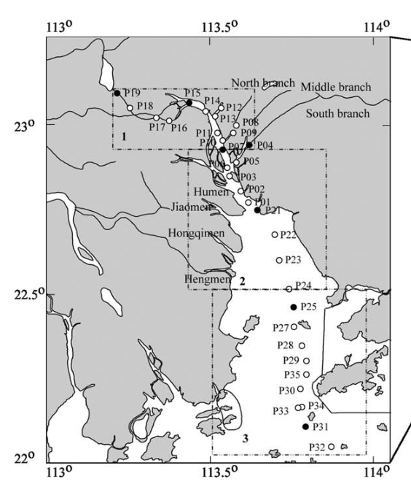

**Supporting Information** Figure 5: Map of sampling station in He et al. (2010) for DOC consumption rates in PRE.

He et al. (2010) have measured the bacterial respiration rates (RB) and DOC consumption rates (RD) of PRE during April 2007. The sampling stations and values of DOC consumption rates in He et al. (2010) are listed in Supporting Information Table 2. The bacterial respiration rate is defined as the DO consumption ratio per hour, and the DOC consumption rate is defined as DOC removal per hour (He et al., 2010). The sampling stations used for comparison is located at downstream of Humen outlet. The observed values of DOC consumption rates are ranged from 0.04 to 0.12 µmol C L-1 h-1, and the simulated values are ranged from 0.05 to 0.27 µmol C L-1 h-1 (listed in Supporting Information Table 3). Both of them are higher at the Inner Lingdingyang bay (station P21) and decrease to the Out Lingdingyang bay and estuary mouth (station P25 and P31). Therefore, the simulation results of DOC consumption rates can match well with the observation results. The model has good skill in simulating biochemical processes in the water column of PRE.

**Supporting Information Table 2:** DOC consumption rates **comparison between simulation and estimation.**

|  |  |  |  |  |  |
| --- | --- | --- | --- | --- | --- |
| **Upper Lingdingyang bay** | | | **Midele and outer Lingdingyang bay** | | |
|  | **Estimate a** | **Simulate** |  | **Estimate a** | **Simulate** |
| **P21** | 0.12 | 0.15~0.16 | **P25** | 0.04 | 0.25~0.27 |
| **P22** | n.d. | 0.16 | **P31** | 0.04 | 0.03~0.05 |
|  |  |  | **P32** | n.d. | 0.03~0.04 |

a He et al. (2010).

**Supporting Information** Table 3: Simulated DOC consumption rates at the corresponding sampling station.

|  |  |  |  |  |  |  |  |
| --- | --- | --- | --- | --- | --- | --- | --- |
| **Upper Lingdingyang bay** | | | | **Midele and outer Lingdingyang bay** | | | |
|  | **Surface** | **Middle** | **Bottom** |  | **Surface** | **Middle** | **Bottom** |
| **P21** | 0.15 | 0.16 | 0.16 | **P25** | 0.27 | 0.26 | 0.25 |
| **P22** | 0.16 | 0.16 | 0.16 | **P31** | 0.05 | 0.03 | 0.03 |
|  |  |  |  | **P32** | 0.04 | 0.03 | 0.03 |

1. Simulating DOC concentration in pore water compared with previous estimating

The comparison results of DIC in pore water and previous observation are listed in Supporting Information Table 3. While the model has simplified the sediment into the aerobic and anaerobic layer, the simulated aerobic layer is compared with the measurement within the 0-1cm depth of the sediment, while the anaerobic layer corresponds to the measurement within 5-10cm. It can be seen that all of the simulated DIC concentration in the overlying water, pore water of the aerobic layer and anaerobic layer are all well matching with the observation. All of them are higher near the outlets and decrease downstream to the open sea. The concentration gradient of DIC in the anaerobic layer is much higher than that in the overlying water, indicating that the remineralization of terrestrial POC deposited in the sediment resulted in a higher concentration of DIC near the outlets, which further led to a significant flux process of releasing DIC from sediments into the water column.

Cai et al. (2015) also revealed that ‘there was a general trend of decreasing DIC and NH4+ concentrations in pore water from the inner to the outer estuary. DIC and NH4+ normally increased with depth in the sediment. In the inner estuary, depth profiles of pore water DIC and NH4+ were characterized by sharp concentration gradients. In comparison, the concentration gradients of pore water DIC and NH4+ were much less prominent in the mid- and outer estuary. .. Away from the upper estuary into the mid-estuary, the fluxes diminished dramatically.’

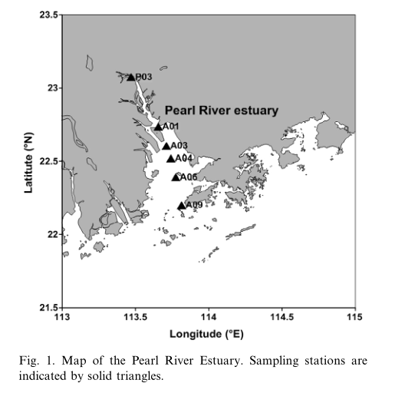

**Supporting Information Figure 6:** Map of sampling station in Cai et al. (2015) for DIC concentration in pore water and overlying water of PRE.

**Supporting Information Table 3:** Simulated DIC concentration in pore water and overlying water at the corresponding sampling station at November 16th -27th .

|  |  |  |  |  |  |  |
| --- | --- | --- | --- | --- | --- | --- |
|  | **Estimate a** | | | **Simulate** | | |
|  | **Bottom water** | **0-1 cm** | **5-10 cm** | **Overlaying water** | **Aerobic layer** | **Anaerobic layer** |
| **P03** | 1303 | 5210 | 13527~15986 | - | - | - |
| **A01** | 1755 | 3070 | 9598~14263 | 1729 | 2914 | 12468 |
| **A03** | 1828 | ND~2103 | 3849~5167 | 1674 | 2383 | 8012 |
| **A04** | 1698 | 1854 | 3344~3732 | 1735 | 1963 | 5915 |
| **A06** | 1886 | 1707 | 1567~2318 | 1795 | 1860 | 4621 |
| **A09** | 1484 | 1774 | 2127~2428 | 1893 | 1624 | 3141 |

a Cai et al. (2015).